ETHICAL ESSEY
THE GOOD DOCTOR: CAN A DOCTOR BE “UNWELL”
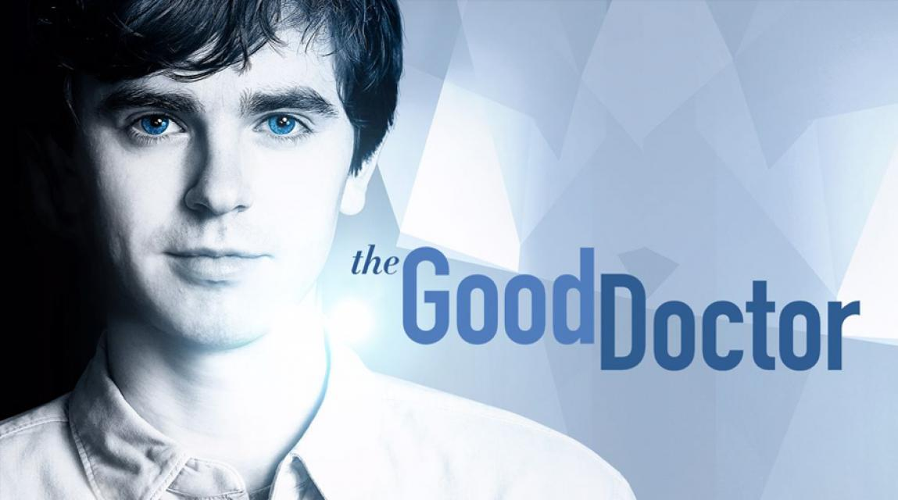
The "Good doctor" is an American series in the genre of medical drama, which tells the story of a young talented autistic doctor with Savant syndrome.
Shaun Murphy- the main character of the series, a resident surgeon, a man with a highly functional autism spectrum disorder and at the same time with savant syndrome. The most mysterious syndrome in medicine, which is a rare condition in people with developmental disabilities, in our case autism, there are so-called “Islands of genius”, it means that there is outstanding abilities in certain areas of knowledge. Thus, savant's syndrome allows him to quickly and accurately determine diagnoses, build multi-level mental maps, keep in mind very complex information from different areas, make unexpected discoveries and save lives when everyone seems to have no way out.
However, in parallel with the autism spectrum disorder Shaun experiences difficulties in communicating with other people and avoids the society. In addition, Shaun's life is painted by the hour, so for example, every day he gets up at 6 am and every subsequent action is recorded by an alarm clock. In one episode it was shown the moment when according to the schedule he had to eat a green apple, but there was not one in the house. This situation knocked him out of the regular schedule, in consequence of which Shaun was furious. People with autism syndrome prefer to live alone and be tied to any objects. In our case, Shaun was tied to a toy scalpel given by his brother as a gift. When Shaun felt fear, he always took out his favorite scalpel, which calmed him.
Anyone with autism avoids tactile contact, so for example, Shaun avoids hugs, touch and direct eye contact. By passing all of the above, Shaun lacks a sense of empathy that does not allow him to empathize with others, which in turn helps to assess the situation rationally, as well as this unique feeling saved Shaun from expressing false and insincere information.
All these features encourage the viewer to think about the compliance of all these qualities of the doctor's profession.
In this essay, we would like to consider whether a doctor may be unwell and whether the combination of medical skills and incurable disease is ethical from our point of view. To begin with, it is worth noting that our acceptance or rejection of the movie character directly affects the point of view in real life. In other words, taking for themselves the possibility of the existence of an unhealthy doctor in the TV series, we automatically allow it in reality. It is worth noting that this perception is influenced by some factors that are known and sometimes are used by the filmmakers. All of them will be discussed below.
First factor affecting on our perception is a public opinion, which always divided into supporters and opponents. To examine this aspect more attentively we should consider this issue from several points of view.
Whether it is ethic in relation to people with deviations, such as autism, not to allow them before work?
Ethically in relation to patients to allow to work of people with mental deviations, such as autism?
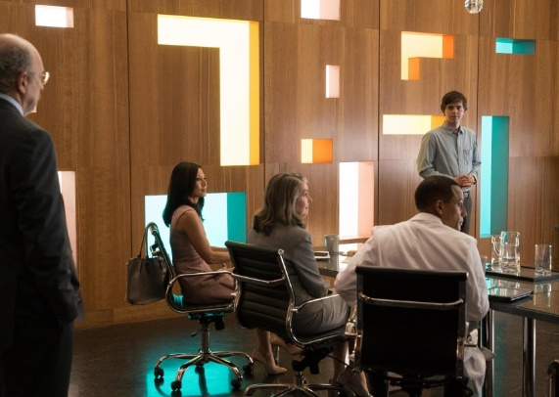
1 series of 1 season: a meeting of the Board of Directors of hospital concerning acceptance to a position of the surgeon of the doctor sick with autism, doctor Shaun Murphy.
Our following case is based on 1 series of 1 season of series "Good Doctor" where the issue of Shaun Murphy's acceptance to the surgeon-intern's position in clinic is resolved. We consider that for the best understanding of a case it is necessary to transfer a small part of series with citation therefore further you can see a discussion concerning Shaun Murphy's candidacy:
"-The mental disorder which is characterized by difficulties at communication and at perception of abstract concepts – here its definition. Not the best characteristic for the surgeon.
- He is not a rain man. It has high-functional autism. Shaun is capable to take care of himself.
- Highly functional? Here, so what we employ.
- Really, about you you will not tell it. Colleagues, unless it is obligatory? To convene a special session of Board of Directors …
- Will you appoint him the surgeon-intern in my department though I against?
…
- It underwent testing, as well as any other candidate.
- Did not you think that council can refuse to employ the surgeon to whom diagnosed autism? Explain the decision.
- I met Shaun Murphy when to him there were 14. He was and remains the extraordinary young man. He is not just an Autist, it has Savant's syndrome. He is ingeniously talented person, it has an ideal memory, a magnificent eye estimation, he understands and analyzes the world surrounding it in a unique way as we cannot even imagine. It the advantages undoubtedly valuable to any doctor, and, especially, for the surgeon."
- The surgeon not only speaks with patients, but also sympathizes with them. Shows empathy. Doctor Murphy can do it? He even could not come to an interview! You what, you want to tell that there were no other qualified young surgeons who had no its problems?
- Were. And therefore, for this reason we have to take Shaun. We will employ him because it is qualified and is not similar to others. Quite recently we did not hire in this hospital of black doctors, and earlier we did not even employ female doctors.
- It turns out, you compare the Afro-Americans and women to autists? I ask, continue.
- All right. Here the same logic works. There was talk on temperament earlier: "About is not present, no what will be told by patients?!" Our attitude towards people around characterizes us not as doctors and as people. Especially the attitude towards those who are deprived of those opportunities that is at us. Having employed Shaun, we will present hope to other autists, we will show that their shortcomings actually are not a hindrance that they have a chance too. Having employed Sean, we will make this hospital better, we will employ him, and we will become the best people.
- We will be the best people who will pay for negligence of the doctors.
…
- Who agrees with doctor Glassman and approves Shaun Murphy's candidacy?
* 2 voices *
- Who against?
* 7 voices *"
Further Shaun Murphy saves life of the boy who gets to this hospital, Board of Directors sees it alive, estimates its actions from the professional point of view and nevertheless employs Murphy to the surgeon-intern's position in spite of the fact that there are opponents of this decision.
From this case the question whether it is logical to employ people with mental deviations, such as autism, to a position of the doctor follows. This case needs to be considered in relation to two opposite parties: in relation to doctors- autists and in relation to patients. Such formulation of the question is necessary for the reason that unilateral consideration of a problem does not reflect all situation, and some of the parties can remain unaffected that will negatively affect a research.
First of all, we consider a case from ethics in relation to the doctor. Whether ethically to refuse to the person work, not in view of at the same time his professional skills, personal qualities and even without having communicated to him personally? It would seem, the answer is absolutely obvious here: no, unethically. However, in this situation the huge role is played by one aggravating circumstance: the doctor is sick with autism. Let us consider the relation to this fact on the basis of the series.
The outcome from series, an issue of acceptance of doctor Shaun Murphy for work was resolved on Board of Directors of clinic. Initially most part of council voted categorically against, reasoning the decision only with Murphy's diagnosis. One of doctors, the manager of surgical office (that is future immediate superior Murphy), identified autism as follows: "The mental disorder which is characterized by difficulties at communication and at perception of abstract concepts – here its definition. Not the best characteristic for the surgeon." We see that the doctor insists that the doctor sick with autism is incapable to perceive adequately those things which for ordinary surgeons are usual; besides, one more "side effect" of autism is at once traced here – Murphy can have problems at communication with patients who easily could be avoided, it be "healthy". Thus, we allocate two basic reasons of refusal at acceptance for work: inability to work in collective on an equal basis with all and difficulties at communication with patients. In series the thought is accurately traced that these two reasons are enough for refusal in a position, and heroes of series consider it ethic.
In this case, most of doctors lean on facts of common knowledge about autism and analyze possible problems which can arise at the surgeon with this syndrome. By the way, treat syndromes of autism: disturbance of the speech, socialization problem, aggression attacks, lack of emotional contact with people, stereotype of behavior and fear of changes. It expects collective to see Shaun Murphy, then and their decision in refusal is caused.
However, in this discussion there is an opposite side, the party of protection of Shaun. The doctor voting for a positive outcome of a dispute reasons the decision as follows: "It has high-functional autism. Shaun is capable to take care of himself. […] He is not just an Autist, it has Savant's syndrome. He is ingeniously talented person, it has an ideal memory, a magnificent eye estimation, he understands and analyzes the world surrounding it in a unique way as we cannot even imagine. It the advantages undoubtedly valuable to any doctor, and, especially, for the surgeon."
We see that the fact earlier unknown to Board of Directors is added to all other: Shaun has high-functional autism, Savant's syndrome. What does it mean and as has to influence the common decision?
High-functional autism (English High-functioning autism (HFA)) — the general disturbance of development, one of autism forms. The term concerns people with autism whose intelligence quotient (IQ) more than 70 therefore their cognitive abilities are estimated as "high-functional". Difficulties in social skills and some awkwardness and also delays in speech development, characteristic and for some other forms of autism are considered as characteristic features of high-functional autism.
Thus, as we can see, high-functional autism possesses those symptoms complicating life, as usual however a brain of people with a similar syndrome as if quicker works that makes them practically by geniuses. By the way, Bill Gates and Albert Einstein, Dan Aykroyd and Daryl Hanna "had" high-functional autism. Besides, it may be noticed that our hero also possesses Savant's syndrome.
Savant syndrome, sometimes in abbreviated form a savantizm (from fr. savant [sav ɑ̃] — "scientist") — a rare state at which persons with a deviation in development (including autistic character) have "the island of genius" — the outstanding abilities in one or several fields of knowledge contrasting with the general limitation of the personality.
So, now we have a full picture: Shaun Murphy not just the autist with deviations in development, he is natively ingenious person with expanded abilities of a brain, however possessing symptoms of usual autism, such as difficulties in communications and deviant behavior.
On development of series, these facts did not convince doctors of clinic of the theory, and they continued to adhere to the position up to the moment when Shaun saved the boy at the airport by means of make-shifts. This case and personal direct contact with Murphy confirmed his professional skills and demonstrated that "the island of genius" by means of which Murphy could make what the ordinary surgeon did not even think of.
However, the critical situation with the boy also reflected a negative side of the diagnosis. At the responsible moment when doctors needed Murphy's opinion on the course of operation, he could not formulate accurately the thought because of strong nervousness which "confused" his consciousness. Thus, the communication problem was shown.
So, returning by the beginning of the case, we ask again: whether ethically to refuse to doctor with autism work? According to series it is possible to draw a conclusion that is not present. The Board of Directors came to such conclusion, having estimated all advantages and shortcomings of the similar worker. On the one hand, the doctor sick with autism can be inefficient in emergency and critical situations because of problems with communication, but from other party, in similar situations he on the contrary can act quicker and more competently than ordinary people for the reason that neurons in his brain work several times quicker. Besides, the situations requiring extraordinary solutions for people of this sort are not desperate as their brain is not able to work banal, as leads to ingenious outcomes.
Transferring a situation to real life, we understand that the case described in series is exclusively private. First, the surgeon has not just autism, and a certain syndrome which provides it some advantages. Secondly, the positive decision on acceptance for work was promoted by a private situation into which the hero got in a random way, having appeared "at the right time in the right place". Thirdly, one of the doctors entering into Board of Directors zealously defended Murphy's candidacy. In this case the refusal in a position would be unethical in relation to the doctor, and the answer to our initial question would be "no".
If to think of a real-life situation when the doctor sick with autism tries to get a job in clinic, it will become obvious that, with high probability, it will be waited by refusal. The symptoms peculiar to ordinary autism and unavailability of society will be causes of failure to see people with a similar syndrome in a health care field. Adequately assessing a similar situation, we can tell that in this case the refusal would be ethic as in medicine there is no opportunity to think only and the doctor, the patient here on the first place.
Thus, we turn to the second question of our case: and whether ethically in relation to the patient to allow to work of the doctor with autism?
In this case the answer is influenced by several factors: besides, a form of autism and the related symptoms, skill level of the similar specialist, readiness of other personnel of hospital to support and direct the doctor with autism and, first of all, the relation of society to this fact. How will people apprehend the doctor autist? Whether his behavior in work with patients will differ from behavior of ordinary doctors? Whether the stereotypes imposed by public opinion concerning the matter will play in this case a role?
Proceeding from the current case, in relation to patients the similar decision will be unethical as society is definitely not ready to similar, and probably people will perceive extremely sharply the doctor-autist.
Second factor is an artificial idealization of the image using the techniques of cinema.
During a watching of this serial we found out an interesting thing: a main character, who has a very strong disease like autism is created to much cute and nice, and the consequence of such attractiveness can be a sympathy for him and his illness. However, is it good or bad? General age group of watchers of serials are teenagers, whose psyche is enough flexible to get new ideas and points of view.
And the question is, is it acceptable to idealize and romanticize an illness? Is it ethical to show the brightest side of horrible things in movies?
Our hero is ill and has two different diseases: Autism and Savantism, which should influence on his behavior very significant. However, we should compare the reality and movie. As was said, Savantism is a special form of pathological changes in the brain that have left an imprint on its functioning. The name of this disease speaks for itself. A person who is subject to this pathology can be an owner of outstanding abilities in one or simultaneously in several fields of knowledge. As a rule, they significantly contrast with the General limitation of the patient's personality and appear quite unexpectedly.
Patients with Savant syndrome suffer from a mental disorder in which the perception of the world is disturbed. The deviation in development caused by certain transformations is compensated by the unique ability of patients to have their own "island of genius".
It is this genius that the creators of the series bring to the fore, forcing the audience to almost forget about the reason for this feature.
It is hard to believe, but people with this syndrome, for all their lack of independence, can literally reproduce up to 4 pages of the first heard text or instantly make complex mathematical calculations in the mind. And this, despite the fact that for most patients are difficult the most common things: buttoning clothes, eating and socializing with other people! For this reason, the main symptom of this syndrome is obvious inferiority, mental retardation in combination with amazing memory.
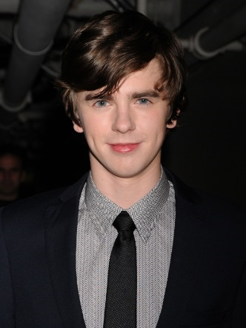
Now we have a question, why a character still became more and more attractive for watchers and why they do not see a real problem?
Firs of all, we should highlight an actor for this role. Freddie Highmore is extremely sweet boy, whose face able to distract the viewer from the unpleasant aspects of the disease. In combination with the "childish" behavior, which is associated with the manifestation of autism, this image makes the viewer except that the main character is touched. Nowadays, many filmmakers use such technology, where negative traits or features of the character is smoothed due to the pleasant appearance. That is why we often want to sympathize with the villain more than the main positive character.
Secondly, we should remember the modern trend of sick heroes. More and more movies offer us a beautiful story about a character whose illness is seen under the prism of a love line or a struggle with the world, which makes it something of a norm. Therefore, meeting a perfectly healthy character, the audience thinks it bland and undramatic.
Therefore, is it ethical to make an ill character too much sweet and positive?
The strongest influence of television affects Teens. An adult can understand that not everything seen on the screen is the norm, but a teenager is not always. All kinds of reality shows are so embedded in the subconscious that the child begins to behave like his favorite hero. In this case? An illness becomes something attractive and desirable. Of course, it doesn’t mean, that a person will becomes ill to, but such image can lead to the range of consequences, like the desire to find some fashionable disease or diagnose depression.
So, we think, that it isn’t the best way to demonstrate a tolerance of movie’ creators and translate an idea of similarity through the creation of an extremely perfect character with disabilities.
And the last factor that affects the perception of the picture as a whole is our personal impression of the action and its consequences, which we are able to analyze and draw conclusions.
Differences in the self-development leaded to changes in the behavior. For our main hero all humans’ diseases were like an interesting challenge or a mystery, which should be solved in any way. Now we should consider an ethical aspect of applied methods during a treatment. Was a Shaun’s behavior ethical in relation to patients or their families?
Let us consider some examples from movie, where decisions of main character were controversial
In first case, wanting to make sure that the terrible diagnosis of the little patient is correct, Shaun goes through all the diseases and finds the unlikely possibility that the previous tests were not completely correct. But is it right to give ghostly hope to a boy and his parents who have already resigned themselves to the inevitable?
-What if they need to know truth?
Such words became the main reason for Shaun, when he argued to give a hope to boy’s parents. In Shaun’s mind, the right way or truth must be found under any circumstances. that is why when achieving their goals, the main character does not pay attention to the feelings of other people or the legal side of the issue. So, without the consent of the parents, the doctor intends to do a spinal cord puncture to get the material for research.
On the one hand, his goal was very decent: find a cure and save a life of little boy. But on the other hand, his methods gave the patient and his family false hope. does this mean that the heart of loving parents was broken the second time they heard that there was no salvation?
Considering this case from deontological point of view, we can say, that here actions in general was more important. Here we may try to use a Golden rule. Would you like to know even about the minimum chance of salvation? I guess so. But would you like to hurt your loved ones or hope for a deliberately losing outcome? In this case, the answer is more difficult. We think that only the patient can give or not give his consent to the doctor's action. And if the decision is received from a person in his right mind, no one has the right to challenge it.
The boy accepted his diagnosis and did not want to upset his parents once again. But only by giving in to the enthusiasm of the doctor, he took the risk associated with the treatment. In other words, he changed his point of view under the influence of others. So, doctor’s decision was unethical, since he pursued only his own interests, suitable for his understanding of the norms of behavior.
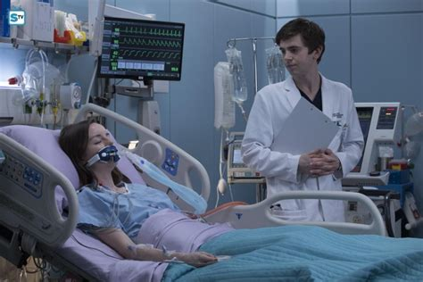
In second case, a teenage girl with facial muscle atrophy, the consequence of which is a complete inability to Express her emotions, is admitted to the hospital. Living in society, this disease brings the girl a lot of difficulties. During the consultation Shaun intervenes and reports all possible complications with a seemingly simple operation
- It sounds like you really care if you're willing to risk your life on a routine surgery.
A doctor has frightened the girl with this phrase, forcing to think about the possible consequences of the operation. She eventually changed her mind and refused the surgery. So why did the doctor do it?
- We must be honest with patients when discussing risks and benefits.
As we wrote earlier, an autistic person is able to think only straight, that is why some features of human communication are lost.
- There are a lot of possible complications, and there is no medical need and it is expensive.
As we can see, there are only measurable factors for it, such as necessity, financial situation etc. In this case a doctor can’t understand such needs like “to be accepted in society”
- I don't want to be understood.
Such wards Shaun told a girl before an operation.
So, we can consider this case in two steps. Firstly, let’s use a Categorical imperative. The universal rule will be to make decisions that are more necessary than human desire. Thus, we reject a Principle of Freedom. Everyone can make decisions according to your desires and needs. And if this is not possible, then the universal rule cannot be considered as ethical.
Secondly, we use an example of Golden Rule. Shaun, due to its peculiarities, evaluates people by itself and does not think about the differences in behavior and the degree of socialization. However, in the case of a doctor, this approach is unacceptable, because needs of patient should always take the first place.
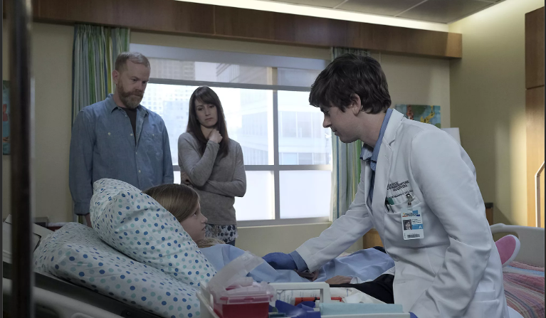
There was also an accident, when the chief doctor instructs the young man to take care of emergency patients who have applied for help with trifling problems. Murphy will learn that not all visitors to the clinic need a close check of their diagnosis, as well as learn to prioritize the examination of patients.
A girl with abdominal pain enters the Department. Parents like most doctors considered it a way to attract attention and stop the constant quarrels of parents. Dr. Shaun Murphy has a different opinion, which breaks in at night in the child's home to check her well-being. This decision saved girl’s life, because she started to suffocate at night.
But let’s consider this act more attentively. Is it acceptable to break into people's private lives, against their will, in order to test their guesses? We think, that in general, answer is no. If we continue use deontological approach, we should estimate Shaun’s decision as bad one. All people have to listen to other people's opinions and respect their decisions regardless of their own thoughts. So, can we regard it as absolutely unethical action?
Also, no! We shouldn’t forget about the profession of our hero. He’s a doctor and his main goal is to save lives. In previous cases we saw, that sometimes such goal can hurt somebody. But here we should pay attention on girl’s parents. They were more passionate about their showdown than the health of the child. In that case, you might find their opinion incompetent.
Let us turn to the Hippocratic oath: "I direct the regime of the sick to their advantage in accordance with my powers and my understanding, refraining from causing any harm and injustice. In whatever house I enter, I will enter there for the benefit of the sick, being far from any intentional, unrighteous and harmful". Let’s imagine the society, where all civil servants are willing to do anything to help a person, without thinking about how it will affect themselves. In this case, perhaps society was a lot better because in the first place would put the needs of 1ordinary people So, using Veil of ignorance, in this context, Shaun’s decision can be ethical.
Trying to make a conclusion, how can we estimate the doctor’s behavior?
Let’s imagine, that people would guide only by their own desires and concepts of correctness. On the one hand, there were no medical mistakes, which could lead to death or other disasters. But on the other hand, a doctor has much more charges. Considering the above cases, we must remember that the task of the doctor is not only to cut and then sew. Interpersonal relationships and communication with patients play a huge role. In this area, our hero has some problems.
Therefore, we can say, that Shaun’s actions were mostly unethical, from the patients ' point of view.
And now we should to sum up some results:
- The society is not ready to accept the opportunity of a doctor with some illnesses, because of some prejudices and traditions.
- The cinematographers use beautiful images and incomplete information to create the perfect "case", where an audience see not a person suffering from a particular disease, and a bright image of genius, which can’t prevent even the disease.
- All Shaun’s actions are good in general, but almost all of them break generally accepted norms of behavior or personal space of other people.
So, now we can see a picture in general. In order to answer the research questions, we should divide our position into two parts. Speaking of the series itself, the character's behavior is not unethical or wrong. However, it is worth considering that the task of the creators of the project was to show the ideal version of events, as we discussed above. Thanks to a pleasant appearance, extremely noble motives and a classic successful story, the hero remains extremely attractive to us regardless of his diseases.
Now it is necessary to say more about them. In the series, the doctor has a specific set of varieties of the disease, allowing him to be a genius in his field. However, it is worth noting that this combination is extremely rare. If one of the components is missing, it is impossible to talk about high efficiency or genius in a particular area. Otherwise, the person has great difficulties with communication and simple existence in society.
Therefore, considering a narrow example from the series, we can conclude that it is ethical for a doctor to have some deviations, since it does not harm patients, and sometimes even contributes to the search for non-standard solutions.
BUT
What happens if such equity becomes a universal law?
Is it possible to allow all sick people, without exception, to become doctors, thereby allowing the possibility of errors or inaccuracies in connection with their disease?
Unfortunately, in real life the cost of error is too high (and this is a human’s life). In reality, neither the legal system nor the people themselves are fully prepared for such a manifestation of tolerance. Humanity must take some steps to eliminate possible problems and discrimination. One of them may be the introduction of a testing system for doctors, checking their qualifications and willingness to work with patients. In this case, the decision will be based solely on the results of the test, and not on subjective opinion.
But since at the moment this kind of test does not exist, it is impossible to make hiring this kind of people a universal rule. The hospital will not be able to guarantee a fully objective and professional approach to work in 100% of cases. Therefore, today hiring for a work all doctors with developmental disabilities without exception can be considered unethical due to the possible consequences.
And in conclusion, we would like to note that all the words and actions of the characters can be interpreted in different ways, making it very difficult to give the only correct assessment. Throughout the series, there are many aspects that somehow affect our perception of the character. And each of us must clearly recognize the difference between cinema and reality, as there are many external factors that affect the situation.

