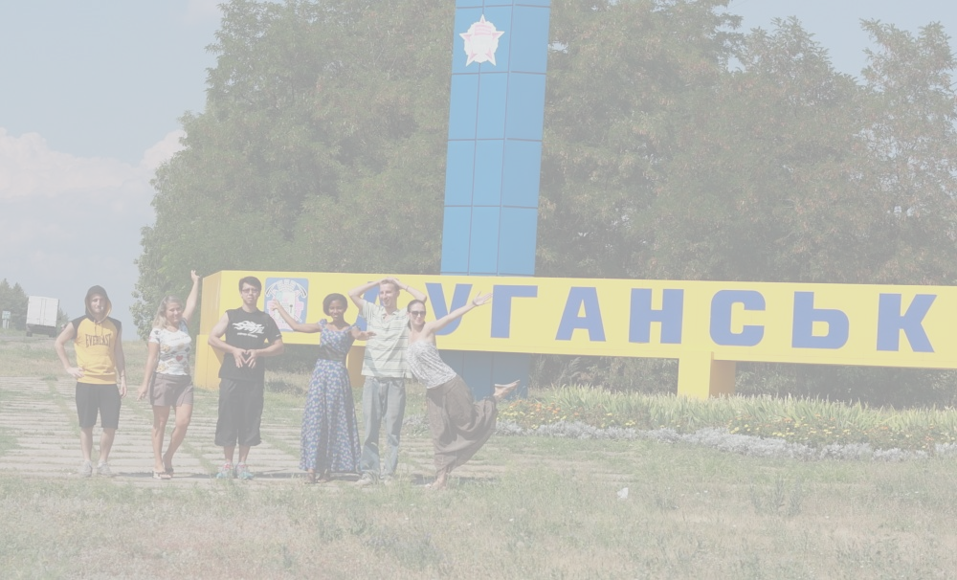
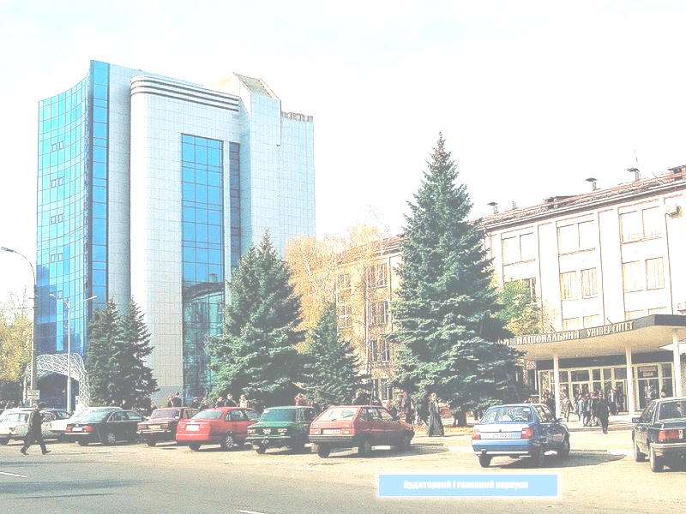
Paul, the USA: “You will find the program at the university to be excellent, the families very caring. The activities are a lot of fun. Take a chance and enjoy. You will survive I promise!”

Chang Sun, China: “I love the whole experience so much! I love the people, food, life style here! I love everything in Luhansk! You’ll love it too!”

Manuel Path, Spain: “I got everything I expected: excellent teachers, amazing tours, interesting activities, perfect language environment for my studies. People in Luhansk are very friendly and I made a lot of friends among local citizens. Thanks to all of you!”

Chai Xiaoxiao, China: “I am so happy I’ve participated in the program “Study & Travel”! It was really interesting and useful for me! The teachers are so kind! I stayed with a local family for four weeks. It helped me to learn more about the local culture and traditions. Food there was very delicious”!

Francisco Vascez, Spain: “This experience was really nice! There were many various, different things to do! It is quite worthy! I feel that I learnt more in one month than in one year! I strongly recommend taking the Russian course in Luhansk! And I hope in future I’ll be able to do that again!”

N. Abraham, Nigeria: “It was a wonderful experience! The teachers are brilliant, friendly and nice! They always carry everybody along. They explained things very well! I also use this opportunity to thank the coordinators, because now I can understand Russian language very good. Your da bomb......”


Study and Travel in Ukraine
Russian courses in Luhansk

Tired of boring Russian classes??? Want to get a new language experience and make new friends in the Eastern part of Ukraine??? You are welcome to realise all of your most bold expectations! Luhansk – is the city of your new opportunity. It is the right step into the clear Russian-speaking future! Our one-month course includes lots of bright and interesting lessons, different activities, full of the Russian and Ukrainian spirit. Join us and you’ll never forget this time.

Our program is unique because it combines educational and cultural travel with an excellent language learning course in the biggest and the best University of Ukraine – VOLODYMYR DAHL EAST UKRAINIAN NATIONAL UNIVERSITY.
What do we offer in the context of learning Russian in Luhansk?
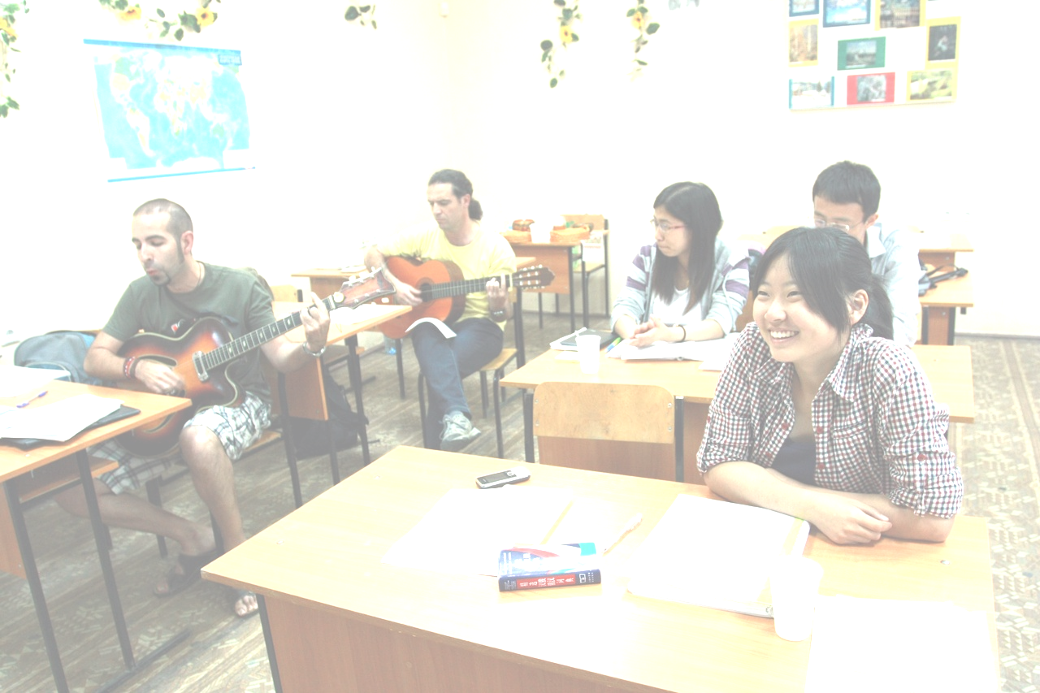
Our main and greatest goal is not only to teach you how to talk, read and write in Russian. We want to make you feel and think in this. And we have lots of opportunities language and a great power to achieve quick and excellent results!!! Our intensive Russian course lasts from one to three months. Every day from Monday to Friday the students have four 45 minute lessons.

The East Ukrainian National University is famous for its professional stuff. Teachers with the 30 years experience of teaching foreigners are ready to make you fluent enough in the great and powerful Russian language!!! They use combinations of different modern methods of teaching. And they are getting the greatest results!!! At their lessons teachers attend all of the aspects of learning the language: oral speech, listening, reading and writing.

Before the start of the course every student takes a language test to determine his or her language level, and according to the results the students are divided into three groups: basic, intermediate and advanced. Each group usually has about six to eight people. Students like their lessons because they are not just learning the rules and doing exercises. They also have opportunity to take part in plays, they sing the folk songs, watch films and share impressions!!! Our lessons are filled with the atmosphere of the friendship and openness!!! Everyone will feel easy here and the Russian language will seem to be simpler.

At the end of the course the students receive a language certificate.
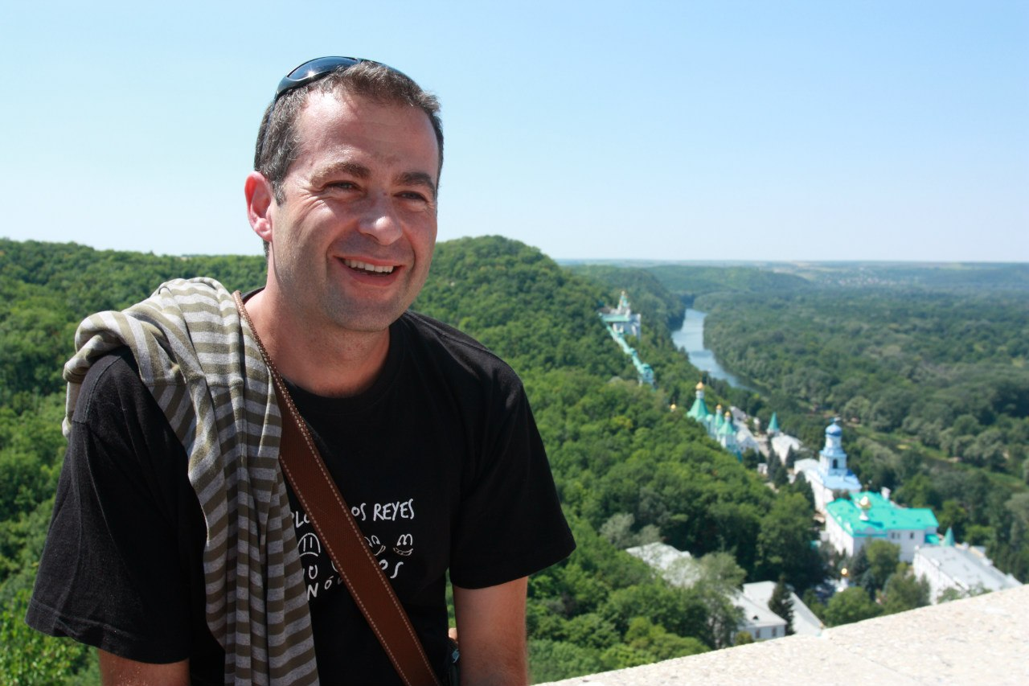
“Study and travel” is not only books and classrooms, but also traveling and exploring, not only libraries and dictionaries, but also real life communication and having fun. You cannot speak the language perfectly until you get to know the culture where the Russian language was born, its history, its land.

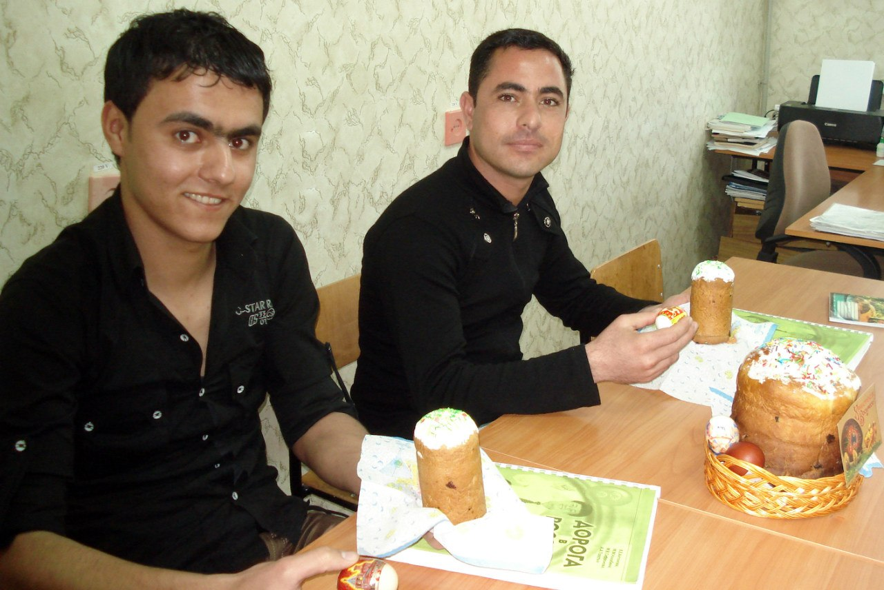

Every week we have at least four or five activities

where students watch old Russian movies, learn

how to cook Ukrainian traditional dishes,

sing Russian folk songs, organize food parties,

and attend concerts.

FIVE great reasons to say “YES!” to your first step into the Russian speaking future with the “Study and Travel in Ukraine”:

1. QUALITATIVE. High quality of education. You will study at the university, not a private school, with teachers, who have more than 30 years of experience in teaching foreign students! Home stay. Living with host families is an opportunity to know more about Slavic culture and customs while immersing yourself in the language and Russian traditions!

2. ENTERTAINING. Almost every day, our students embark on exciting tours and cultural activities as well as participate in Russian lessons. They learn something new all the time and get acquainted with incredible areas of the Eastern Ukraine!

3. VISA. Great news!!! You don’t visa at all to visit our country. You need your passport only!

4. TERRITORIAL. Did you know that Luhansk is rather close to Turkey? Here is a direct flight from Turkey to Donetsk and a couple of hours from there to Luhansk!!! It is much closer than flying, for instance to Moscow or St. Petersburg!

5. STUDENT. You can be sure that in Luhansk you’ll have an opportunity to learn the student’s life. You’ll have a chance to make new friends, to learn more about Luhansk youth and to exchange some thoughts, experience and impressions!

We hope that our courses will find their reflections in your hearts and will bring a big, warm and friendly piece of memories.

Turn on the page and you’ll see some testimonials of our students!

