
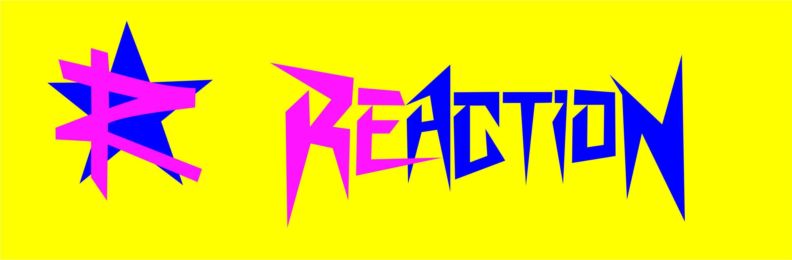

OWNER: ADEL MOSTAFA KAMEL TAHA (tito)
TEL:- (+201020060165)
E-MAIL:- reactionanimation@gmail.com

-Who we are?
REACTION ENTERTAINMENT. Is No limit for perfection

We work, we learn, we progress every day.
The first full legal company at Red Sea which provides for you the best professional service what you need.
U.S.G is a skilled firm in the selection of extremely qualified human resources in the field of entertainment for high level tourist centers with legal license (Hotel, Villages and Resort).
-We improve the real work & the meaning of the animation & the evening life entertainment shows.
-Our teams are multi professional with a lot of experience.

The first Entertainment Company with real management of our entertainers inside the hotel, our management is the way to how can you find the real entertainers in your hotel and they are specialist in all kind of entertainment.

REACTION ENTERTAINMEN This the most important
Rules that make this company successful which are:
1- We give you Respect
2- We are always Smile
3-You are always welcome in our office
4- We make you happy
5- We are always on time
6- Give us all Responsibility

We provide:
- The daily & evening uniform
- Customs for the animation team
- Monthly program of entertainment
- Marketing for the hotel outlet
- we pay one way return flight after complete finishing of 6 month
- we are responsible about sound and light system which provide
for us hotel
( Foam Party – Beach Party – White Party – etc…)
- we make it easy for you with shows organization

☺ We offer for Hotel:

- Animators (Chief Animators, Sport Animators, Dancer Animators,
Kids Animators, D.J.-Animators, Choreographs)
- Full sound and light system
- 14 evening show programs per 2 weeks

☺ The aim of blackout Animation is to offer the hotel customers a
High quality service:

- Animation: •daily sport and games program for children
•daily sport and games program for adults
•daily evening/night entertainment for adults
•daily evening/night entertainment for children

• An international Animation Team:
With members from Germany, Czech, Russia, Egypt,
etc.

• A multi lingual Animation Team (German, English
Italian, Arabic, Russian, etc.)

• A professional Animation Team which is respecting
the guests, times and rules


Number of animators depends on the request of Hotel.

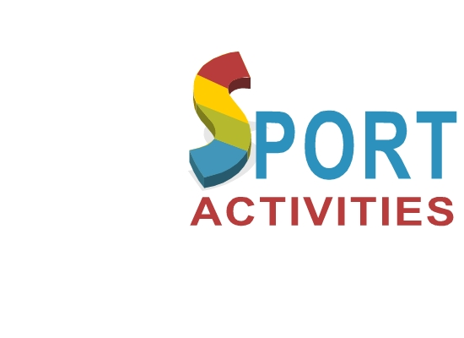
Our aim is to make feel our guests as protagonists of their holidays and to be themselves main characters of the play.
Our daily program is composed of many activities, which are run by our sport instructors and contact entertainers:
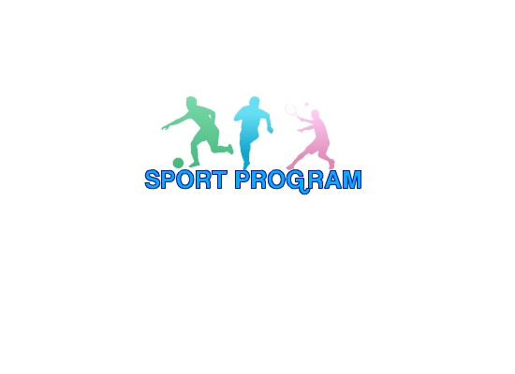
- Beach/Lawn/Pool Stretch & Relax-refresh mind and body with postures to lengthen and relax muscles.
- Yoga – Flexibility and strength training workout which will help you unwind.
- Pilates – fitness class to lengthen your spine and strengthen your core muscles. -
- Aerobics – Fat burning fitness class containing choreographed moves to music.
- Legs, bums & Tums (LBT) Body conditioning fitness class to tone those problem areas.
- Beach Pump-Body conditioning and fat burning fitness using barbells for Enjoyable training
- Step Aerobic-fat burning fitness class using a raised platform, contains choreographed moves to music.
- Circuit training – fat burning fitness class in the water containing choreographed moves to music.
- Water aerobic & toning – fat burning and body conditioning fitness class in the water containing choreographed moves to music.
- Water circuit training – fat burning and body conditioning fitness class in the water containing various station exercises.
- Water aerobic party – fat burning fitness class in the water containing choreographed moves to party music.
- Water-polo – ball game with goals based in the water.
- Water volley – ball game with a net in the water.
- Arabic languages lesson – learn how to speak basic Egyptian Arabic.
- Beach/lawn bolus (bocce, French balls) – gentle ball game throwing bolus nearest the "jack".
- Belly dance lesson – learn how to do Arabic belly dance.
- Salsa dance lesson – learn how to dance salsa.
- Jazz dance lesson – learn jazz.
- Disco dance lesson – learn how to dance disco.
- Rock & Roll dance lesson – learn rock & roll.
- Line dance lesson – learn line dance.
- Beach volley ball – team ball game with a net on the beach.
- Tennis tournament – request provided for the knock out.
- Table tennis tournament (ping pong) – knock out game.
- Swimming pool Olympics – various games, including:
- Swimming relays, canoe race, surf paddle, gladiators and sun bed replay.
- Beach football (soccer) – the number one team ball game on the beach.
- Pool tournament (Billiard) – the table games with spot and striped balls.
- Beach Olympics – various games including: running replays, sea sumo, pole spin, peddle race and beach boy replay.
…will accompany our guest through the whole day.
Animators create an atmosphere of enthusiasm and excitement that are nearby tourists turned their attention to the game and gradually themselves being drawn into the process.
Dynamism, winding nature of competition allows people to be liberated, to show some ability and talent. And, besides, team games and more common.
***

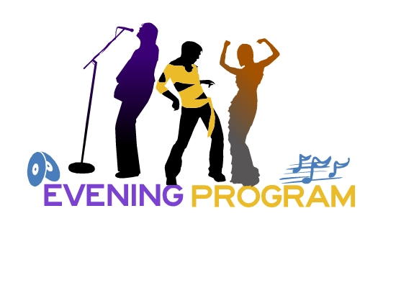

Musicals, Variety, Cabaret….etc.
Our night animation will present you with numberless emotions, while you watch how energy of our artists turns into a pleasant way to perform plays, studied in the least details.
All this is possible, thanks to a specialist team of the sector:
-Set Designers
-Choreographers
-Costume Designers
-Professional Dancers
Work together, as to create that magic atmosphere during night theatre shows.
Our nights end at the disco, where our team will
enlighten the last moments of the day.
Animators will interest both children and adults. Kids will welcome a fun game, but adults will recall with pleasure his childhood, participating in exciting contests.

The evening program includes:
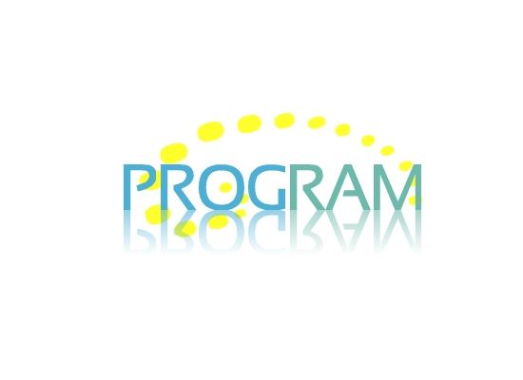
- DANCE SHOW:

- Cabaret show
- Latino dance
- Dances around the world
- Energy show
- American dance show
- Rock & Roll show
- Break dance& R&B
- Irish Dances (Lord)
- M. Jackson show
- Egypt night

- PLAY BACK SHOW& MUSICAL SHOW
- PIJAMA PARTY
- 1000 and 1 NIGHT
- DISCO 80s
- COCTAIL PARTY
- HAWAIIAN PARTY
- FAKIR SHOW
- FIRE SHOW
- COMEDY SHOW
- WHITE SENSATION
- Miss "Hotel"
- Mr. "Hotel"
- Mini-Miss "Hotel"
- Mini Mister "Hotel"
- Ladies against Gentlemen
- Dance charts
- Best Couple of hotel
- Games night
- KARAOKE NIGHT
- ARABIC NIGHT
- TALENT SHOW
- LOTTERY "Bingo"
- Birthday celebration
- BEACH PARTY
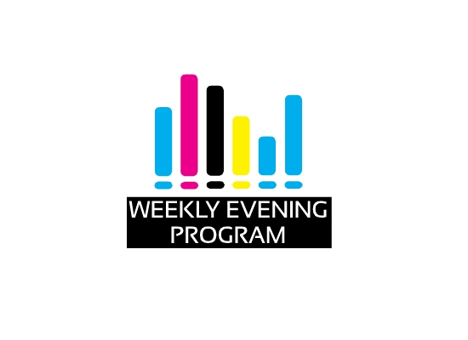

First week:

Saturday:- Karaoke night live
Sunday:- International Dance Show
Monday:- Surprise Show
Tuesday:- Extra Beach Party
Wednesday:- Latino mix dance show
Thursday:- Fire show & Light show
Friday:- Oriental show

Second week:

Saturday:- Movie & Music Quiz
Sunday:- Musical Dance Show
Monday:- Cabaret Show
Tuesday:- Extra Beach Party
Wednesday:- Lord of the dance Show
Thursday:- Fakir show
Friday:- Folklore show

*And more nights programs per week or 2 week.

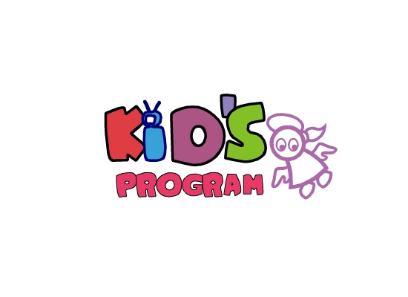
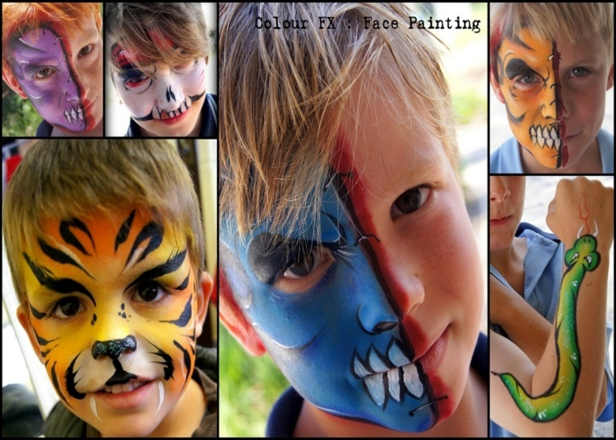
The "Kids Club" is the place where all the children they will find a specialized entertainment staff. Our team will organize activities as recreational sporting practice, pool games. Laboratories of art–attack, mini shows, make up and balloon art, transforming their holiday in an unforgettable experience.

Sport
Our entertainers will organize interesting and complete rest for children, conducting and developing mobile games in the water, as well as:
- Staged performances for children;
- Teach to draw, sculpt, make crafts;
- Organize fun contests;
- Children will learn songs and dances;
- Hold the most interesting adventure games and quests. And in the evening:
- mini-disco;
- Show funny clowning.
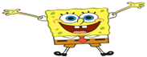
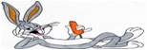
MINICLUBPROGRAM

MORNING
GOOD MORNING | 10:00
MINI CLUB GAMES | 10:30
PAINTING | 11:00
BEACH GAMES | 11:30
CLUB DANCE
  
  12:00
AFTERNOON PROGRAM
GOOD AFTERNOON | 15:00
POOL GAMES | 15:30
MOVIE TIME | 16:00
FACEPAINTING | 16:30
 | 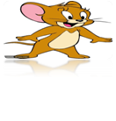  17:00
  SEE YOU TONIGHT
EVENING
MINI DISCO | 20:30
REACTION ENTERTAINMENT
EVENTS SERVICE

- African Show
- Fakir show & fire show
- Events organization & marketing
- International animation teams
- More show business service
And more entertainment services all what you need what you want to do with pleasure with us.
Our team present 2012 – 2017
- MELIA SHARM HOTEL RESORT SHARM EL SHEIKH
- INTERCONTINENTAL PALZA SHARM EL SHEIKH
- MELIA SINA HOTEL RESORT SHARM EL SHEIKH
- SIVA PORT GHALIB RESORT PORT GHALIB
- UTOPIA BEACH CLUB EL QUSSAIR
- HILTON NUBIAN HOTEL RESORT MARSA ALAM
THANK'S FOR COOPERATION
You're sincerely

HOTEL PROVIDES:
- Good accommodation for team
- 3 Meals ( breakfast – lunch – dinner )
- Laundry for every day
- Beverage soft drinks
- Sound and light and all equipment for all extra parties and for all equipment which we need for our shows and plus the maintenance for hotel equipment
- Total amount for the sound and light part and maintenance and technician per month
- Informing before30 days of breaking contract.

- Salary of animator.....................................
- Salary of Chief animator…........................
- Salary of D.J……………………………………..

Thank you!

